Steps to install Java and Jenkins and Java using ansible-playbook on EC2 Instance:

Pre-requesities:
Step 01: Install ansible on ubuntu 18.04
sudo apt update

sudo apt install ansible

step2 ssh to EC2 instance:

ssh i ansibleinstance.pem ec2user@54.226.177.27

note: we may face permission issue here for .pem file
run the following command to resolve:

sudo chmod 0400 ansibleinstance.pem
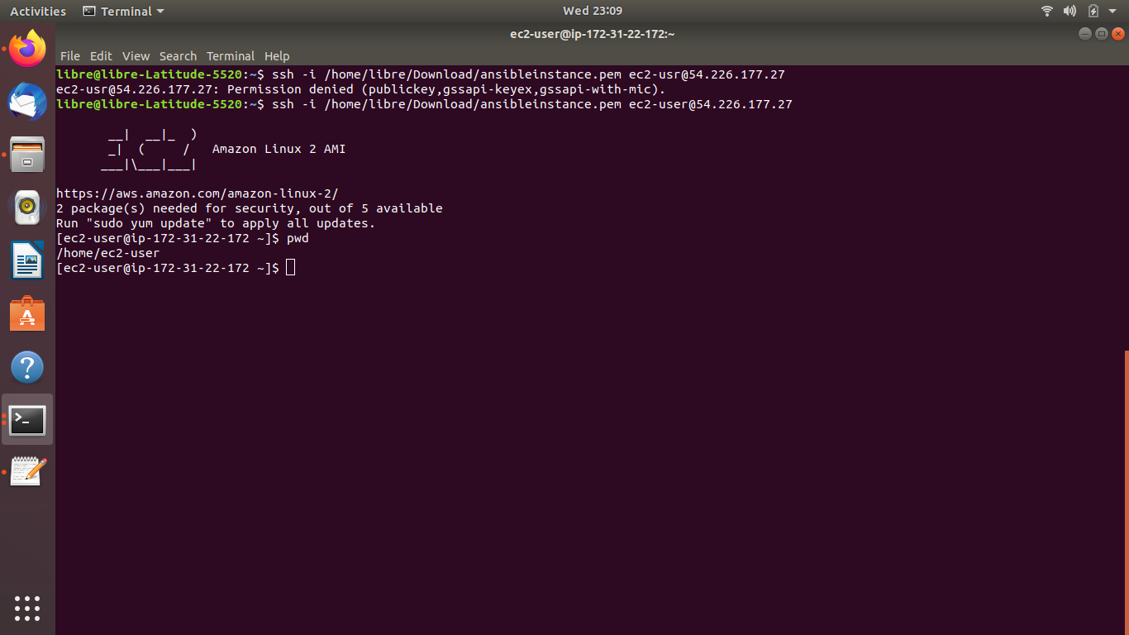

now connection to ec2 instance successfull

step3 keep the following commands in the hosts file in the path etc/ansible/hosts

[target]
54.226.177.27 ansible_ssh_user=ec2-user ansible_ssh_private_key_file=/home/libre/Download/ansibleinstance.pem
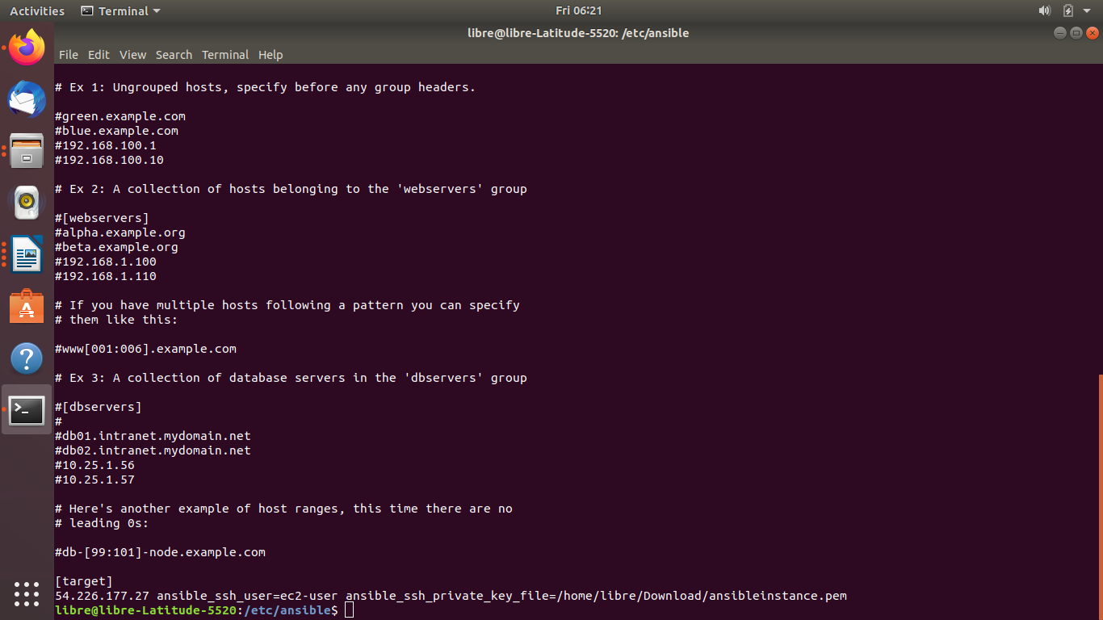

Steps to install java8 on the EC2 instance using ansible playbook:

mdkir java8
cd java8
vi installjava8.yml
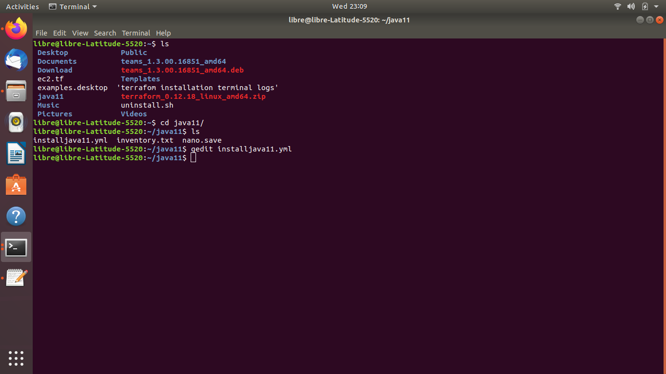

past the follwoing script:
---
- hosts: target
gather_facts: no
tasks:
- name: Update APT package manager repositories cache
become: true
yum:
name: '*'
state: latest
update_cache: yes
- name: Install Java using Ansible
become: yes
yum:
name: "{{ packages }}"
state: present
vars:
packages:
- java-1.8.0-openjdk-devel
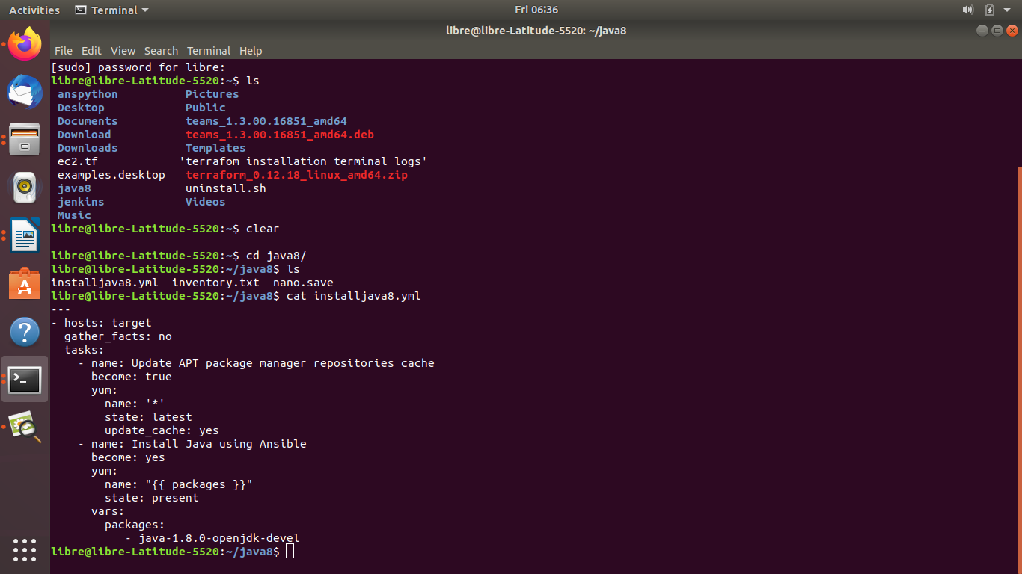

Run the following command:
ansible-playbook installjava8.yml
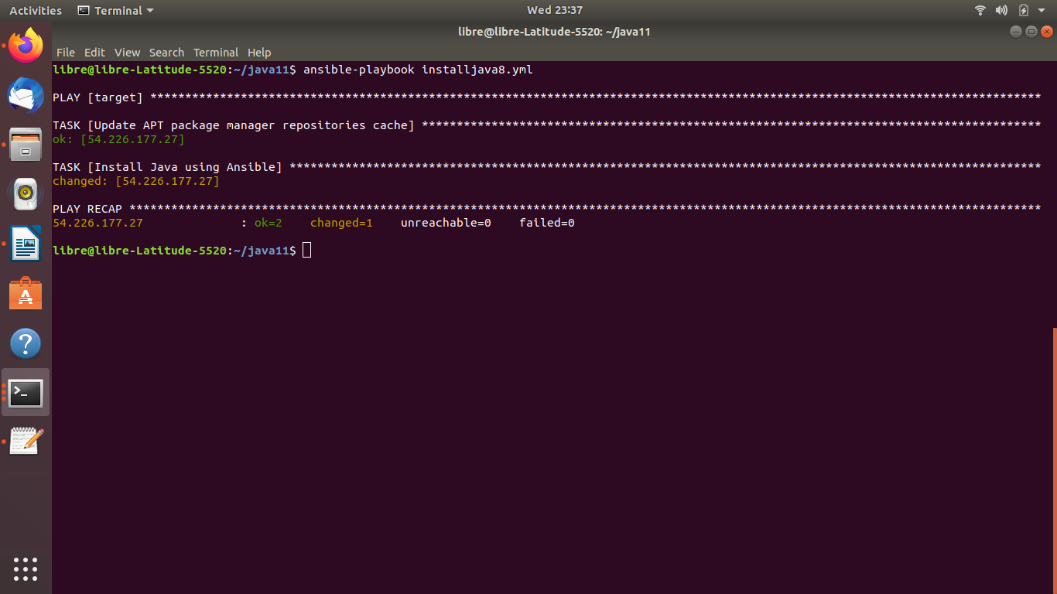

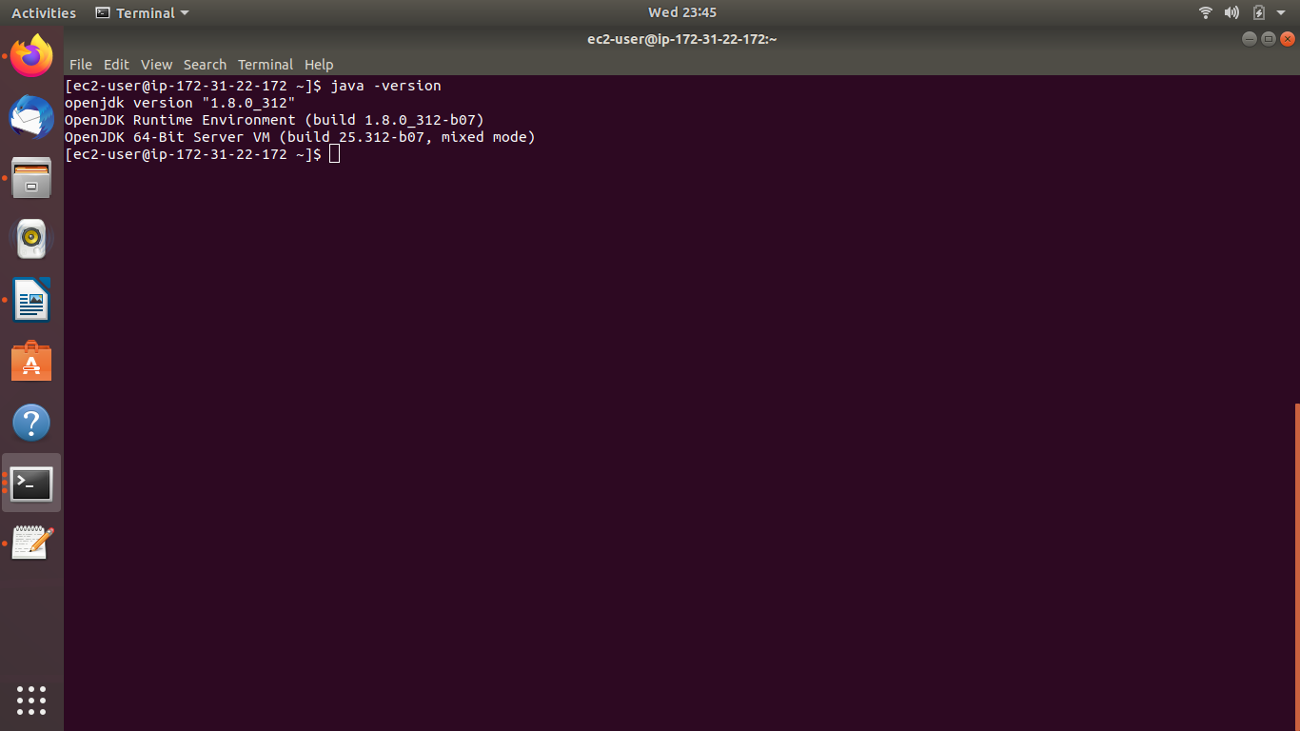
Checking the Java version in EC2 terminal

Steps to Install Jenkins on EC2 Intsance:

mkdir jenkins
cd jenkinst
vi installJenkins.yml

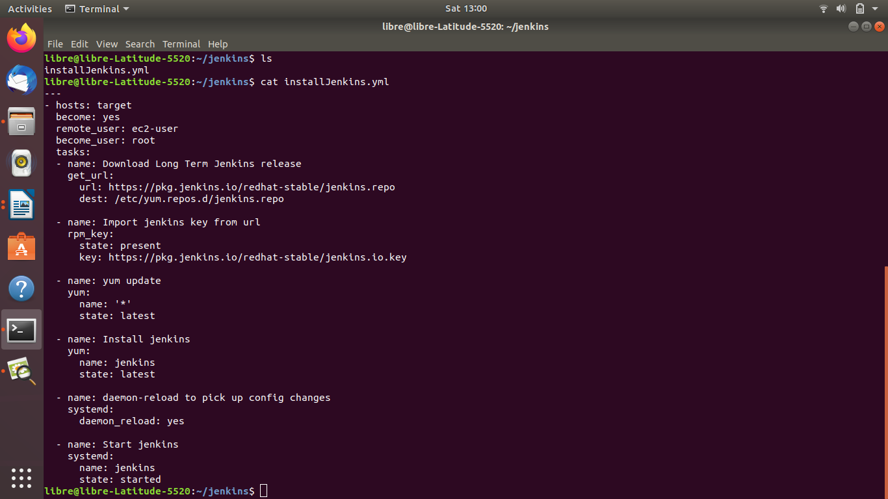
Run using the following command:
ansible-playbook installJenkins.yml

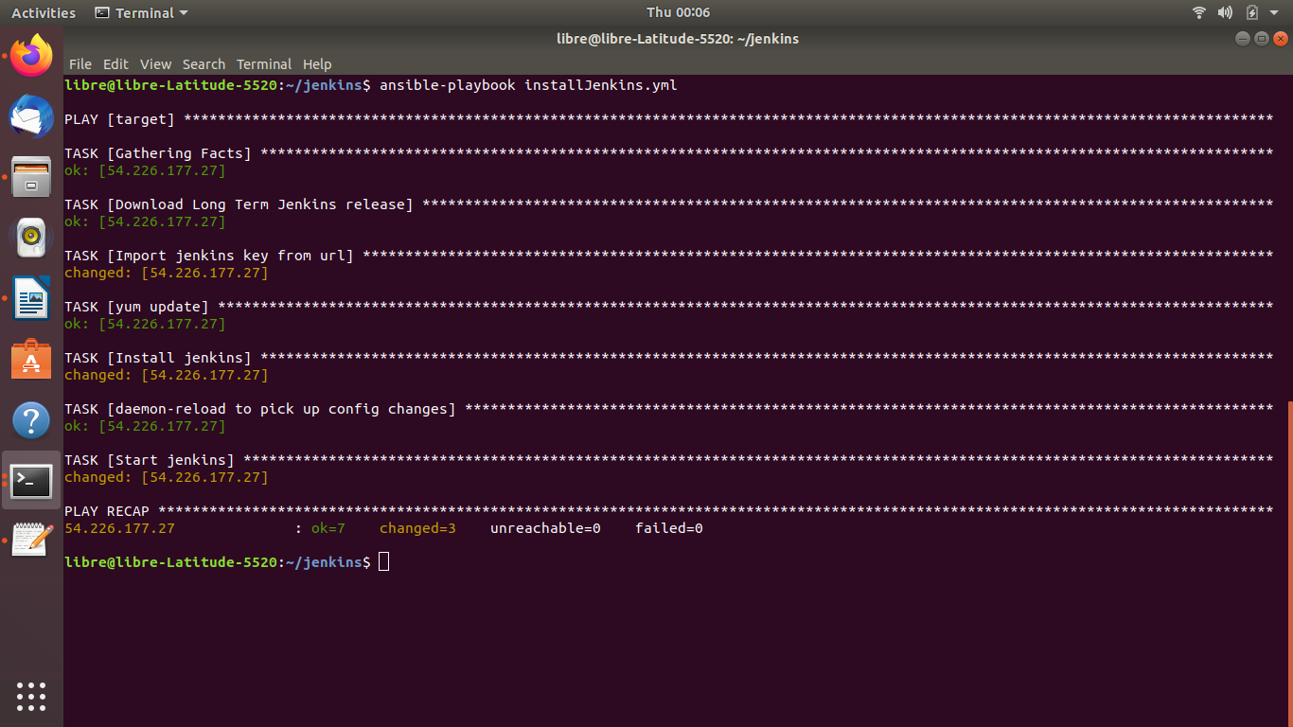
Result as above:

Setting Up Jenkins
1.To set up installation, visit Jenkins on its default 8080 port with your server domain name or IP address: http://your_server_ip_or_domain:8080
You should see the Unlock Jenkins screen, which displays the initial password's location:

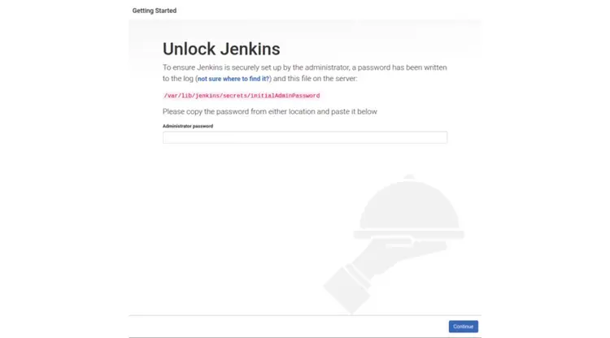

2. You can use the cat command to display the password:
$ sudo cat /var/lib/jenkins/secrets/initialAdminPassword

3. Copy the alphanumeric terminal 32-character password and paste into the Administrator Password field, then click Continue.
0aaaf00d9afe48e5b7f2a494d1881326

The following screen shows the ability to install or select certain plugins


We will click on the option to install proposed plugins to start the installation process immediately.

6. You will see a configuration instance page, which asks you to confirm your Jenkins instance's URL of choice. Confirm either your server's domain name or the IP address of your server.


7. Click Save and Finish once you have confirmed the relevant information. A confirmation page will show you that "Jenkins is ready!"
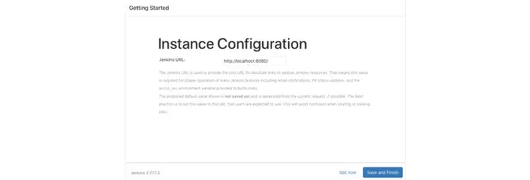
Hit Start using Jenkins button and it will take you to the Jenkins dashboard.

Step 6: Creation of New Build Jobs in Jenkins:
You have to login to your Jenkins Dashboard by visiting


2) Create New item:
Click on the New Item on the left-hand side of the dashboard.


Steps to Install python3 on EC2 Intsance:

mkdir anspython
cd anspython
vi installpython.yml

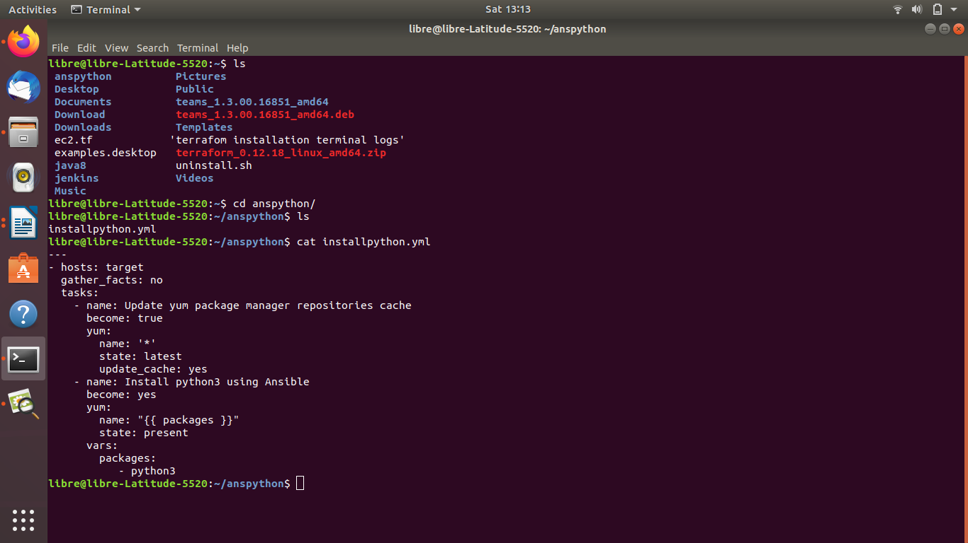

Run ansible-playback using below command
ansible-playbook installpython.yml
